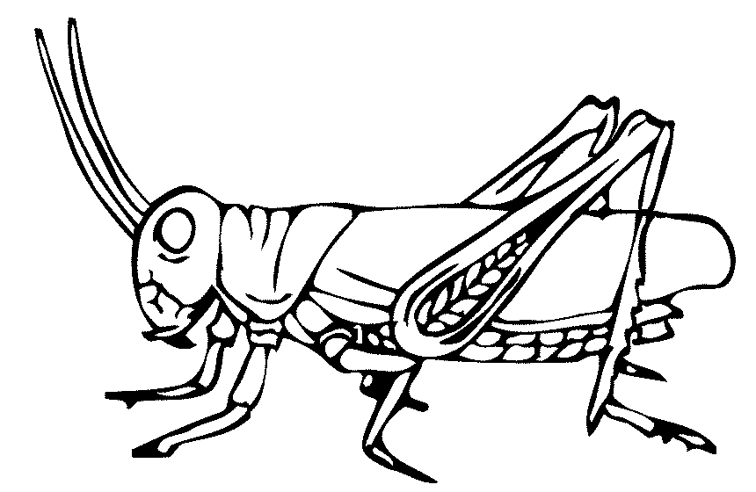
BUGLIFE COLOURING
GRASSHOPPER
BUGLIFE COLOURING
BUTTERFLY

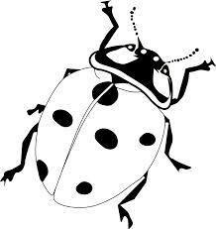
- Insect Crossword:

 |  |  |  |  |  |  |  |  |  | 10
 |  |  |  |  |  |  |  |  |  | 6
1 |  |  | 8 |  |  |  |  |  |  | 7
 |  |  | 2
 |  | 4 |  |  |  |  | 9
 |  |  | 3
 |  |  |  |  |  | 5

- An insect that flies at night | 6) How many years can a worm live?
- This insect lives in a hive | 7) The first stage of an insects life
- How many pairs of wings to most insects have? | 8) What do bumblebees and butterflies do during the winter?
- Who are the flying acrobats in the insect world? | 9) What do bees collect?
- This insect is red with black dots and is hiding behind the crossword | 10) A flying insect that was a caterpillar

- BUTTERFLY Word Search:
Find the words below in the mess of letters.
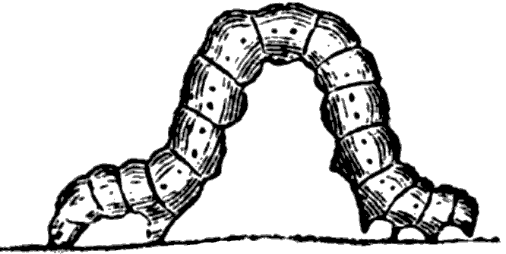
EGG
PUPA
B | U | T | T | E | R | F | L | Y | C
T | O | N | G | U | E | T | L | A | A
D | S | N | E | C | T | A | R | N | T
F | O | O | D | P | L | A | N | T | E
A | P | M | E | A | D | F | P | E | R
S | U | D | S | M | A | R | U | N | P
T | P | T | W | I | N | G | S | N | I
U | A | K | X | Q | L | S | H | A | L
H | I | B | E | R | N | A | T | E | L
E | F | L | O | W | E | R | H | N | A
S | L | K | C | E | G | G | A | W | R
NECTAR
HIBERNATE
CATERPILLAR
BUTTERFLY
FOODPLANT
WINGS
TONGUE
ANTENNAE-
FLOWER

- The Maze:
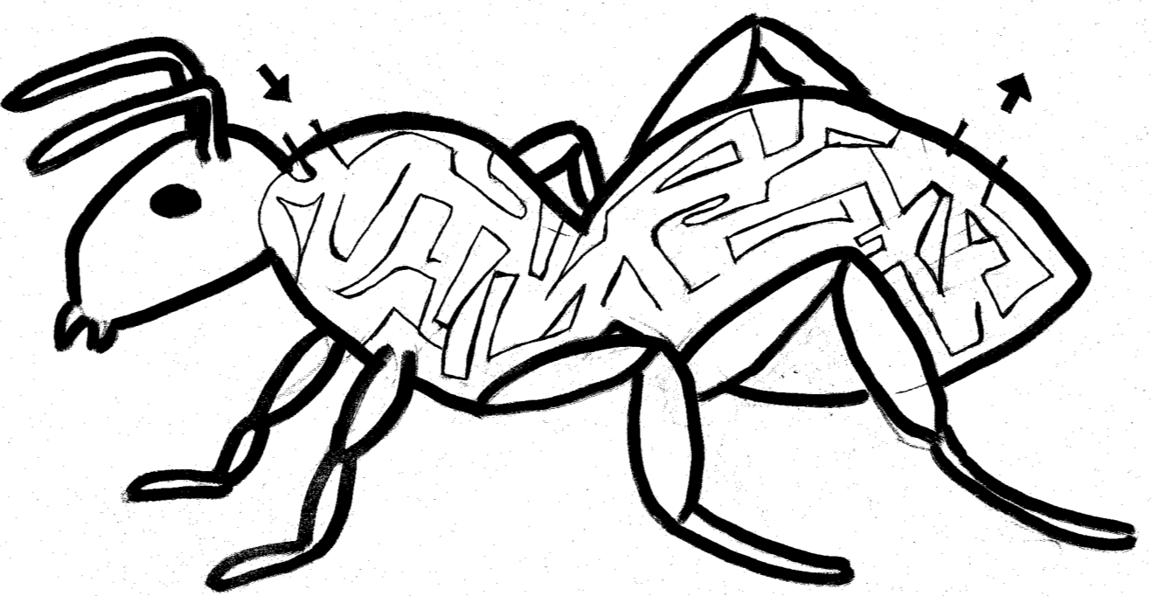
Can you find your way through the maze

Can you spot the differences between a Bumble Bee and a Honey Bee?
The Photographs can be found on Google Image
BUMBLE BEE | HONEY BEE
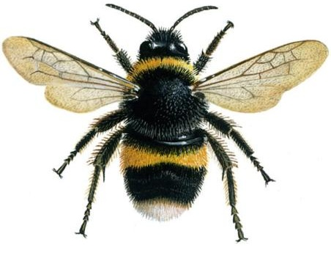 | 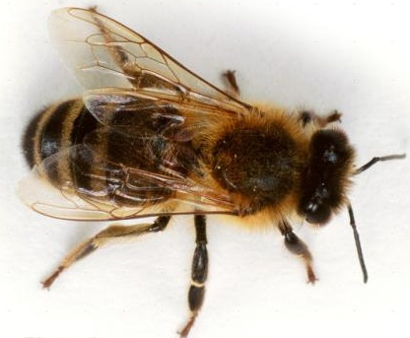
Differences:
Bug Hunt in your garden
Take a quite walk through your garden and see if you can find a bug. When you do pick it up and place it in a jar. Now have a close look at the bug and answer the questions below before you release it again.
(BUT keep the lit of the jar open or places holes in it to keep air in the jar!)
What colour is it?___________________________________________________________
Does it have wings? _________________________________________________________
How many legs does it have?__________________________________________________
Does it have antennae? _______________________________________________________
Can you see its yes?_________________ _______________________________________
What do you think does it eat? _________________________________________________
Do you know the name of the bug?_____________________________________________

Create a Bug hotel

Solution:
Crossword:
 |  |  |  |  |  |  |  |  |  | B
 |  |  |  |  |  |  |  |  |  | U
 |  |  |  |  |  |  |  |  |  | T | E | N
 |  |  |  |  |  |  |  |  |  | T
M | O | T | H |  |  |  |  |  |  | E | G | G
 |  |  | I |  |  |  |  |  |  | R
 |  |  | B | E | E |  |  |  |  | F
 |  |  | E |  |  |  |  |  |  | L
 |  | D | R | A | G | O | N | F | L | Y
 |  |  | N |  |  |  | E
 |  |  | A |  |  |  | C
 |  |  | T | W | O |  | T
 |  |  | E |  |  | L | A | D | Y | B | I | R | D
 |  |  |  |  |  |  | R

BUTTERFLY word search:
B | U | T | T | E | R | F | L | Y | C
T | O | N | G | U | E | T | L | A | A
D | S | N | E | C | T | A | R | N | T
F | O | O | D | P | L | A | N | T | E
A | P | M | E | A | D | F | P | E | R
S | U | D | S | M | A | R | U | N | P
T | P | T | W | I | N | G | S | N | I
U | A | K | X | Q | L | S | H | A | L
H | I | B | E | R | N | A | T | E | L
E | F | L | O | W | E | R | H | N | A
S | L | K | C | E | G | G | A | W | R

