Biodiversity Resources

Pollinators/Planting to benefit biodiversity:

All-Ireland Pollinator Plan – www.pollinators.ie

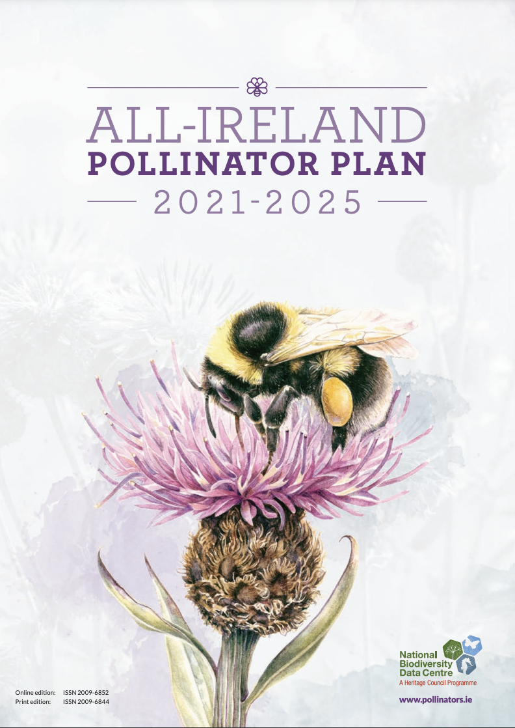
  - All Ireland Pollinator Plan 2021-2025 - https://pollinators.ie/wp-content/uploads/2021/03/All-Ireland-Pollinator-Plan-2021-2025-WEB.pdf

  - Local Communities: actions to help pollinators - https://pollinators.ie/wordpress/wp-content/uploads/2018/04/Local-Communities_actions-to-help-pollinators-2018-WEB.pdf

  - Sports Clubs: actions to help pollinators - https://pollinators.ie/wp-content/uploads/2021/01/Pollinator-Sports-Clubs-guide-WEB.pdf

  - Gardens: actions to help pollinators - https://pollinators.ie/wordpress/wp-content/uploads/2018/04/Gardens_actions-to-help-pollinators-2018-WEB.pdf

All things Biodiversity Ireland:

National Biodiversity Data Centre Resources – https://www.biodiversityireland.ie/
and https://www.biodiversityireland.ie/resources/

- NBDC 10 ways to help biodiversity - https://www.biodiversityireland.ie/biodiversity-irelands-top-10/10-ways-to-help-biodiversity/

- NBDC Shop – An excellent resource for ID guides and Keys to Irish Biodiversity - https://www.biodiversityireland.ie/shop/

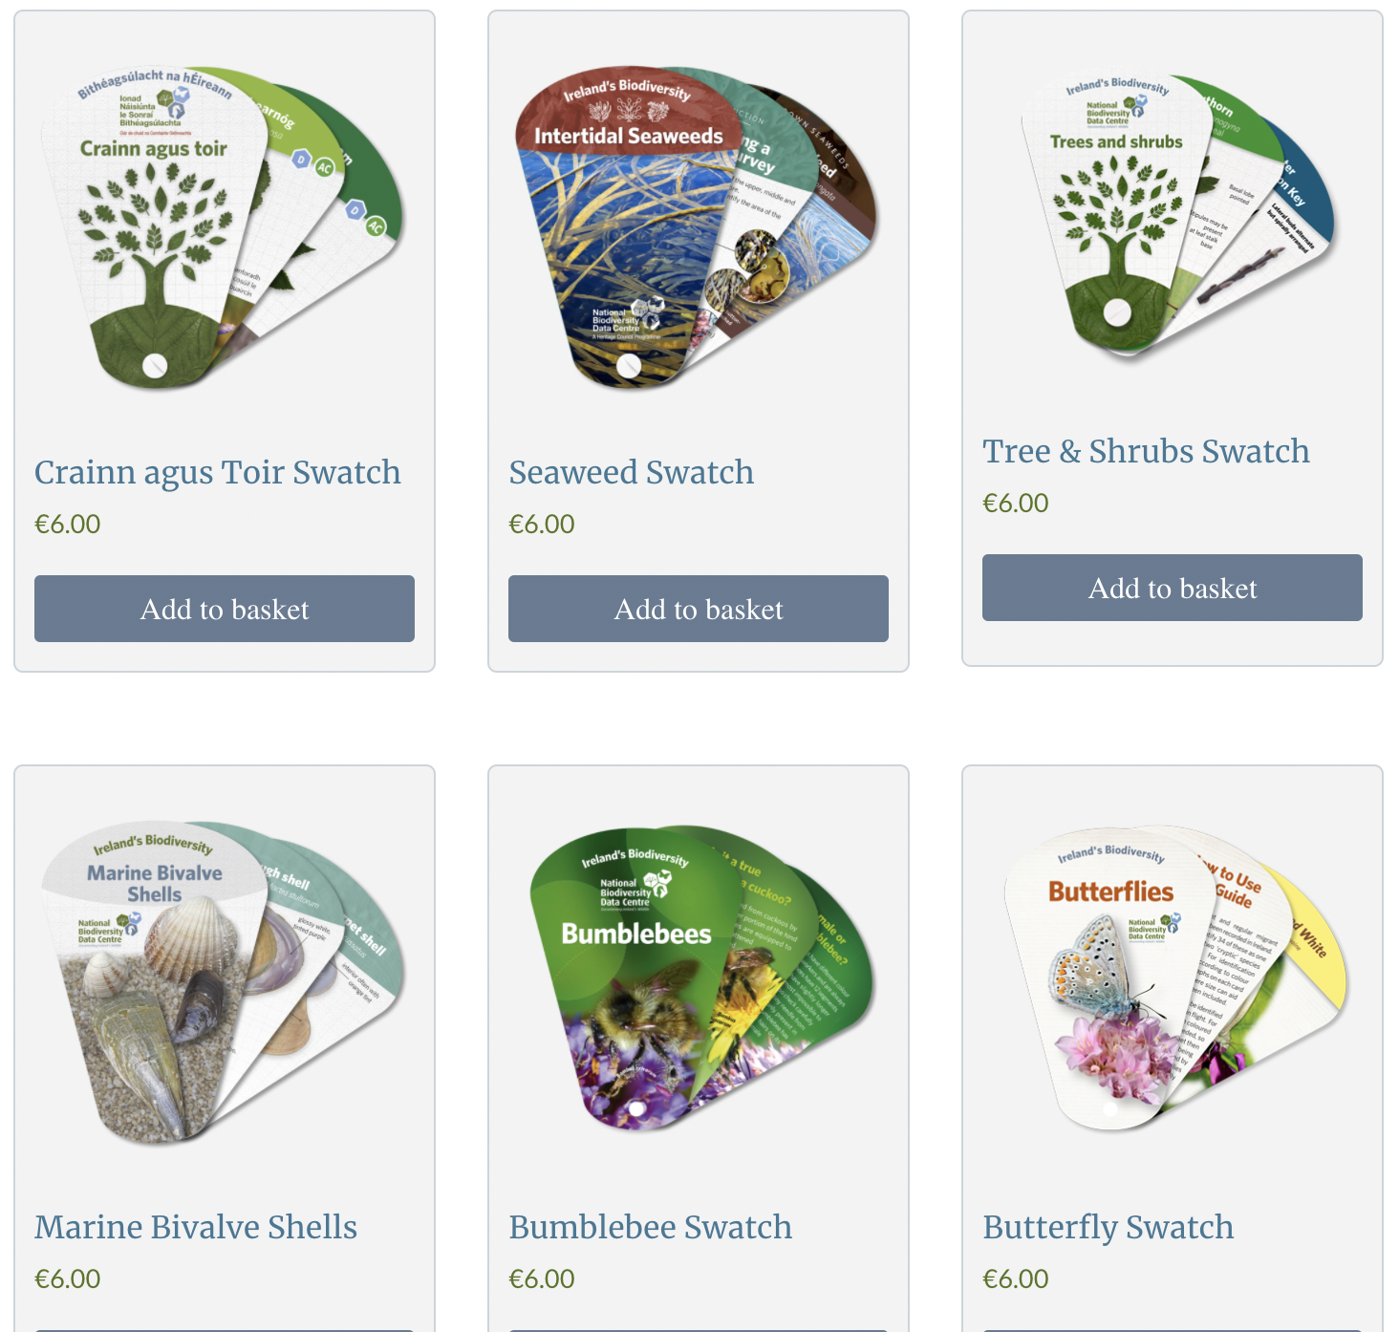
Other Useful Biodiversity Resource Links:

- Trees - https://www.treecouncil.ie/ and https://www.treecouncil.ie/native-irish-trees

- Birds - https://birdwatchireland.ie/

- Bats - https://www.batconservationireland.org/

- Fish - https://www.fisheriesireland.ie/

- Irish Wildlife Trust - https://iwt.ie/

- National Parks and Wildlife Services - https://www.npws.ie/

- Waterways Ireland - https://www.waterwaysireland.org/

- Ulster Wildlife - https://www.ulsterwildlife.org/

- DAERA - https://www.daera-ni.gov.uk/articles/species-northern-ireland

Free Biodiversity Identification Resources:

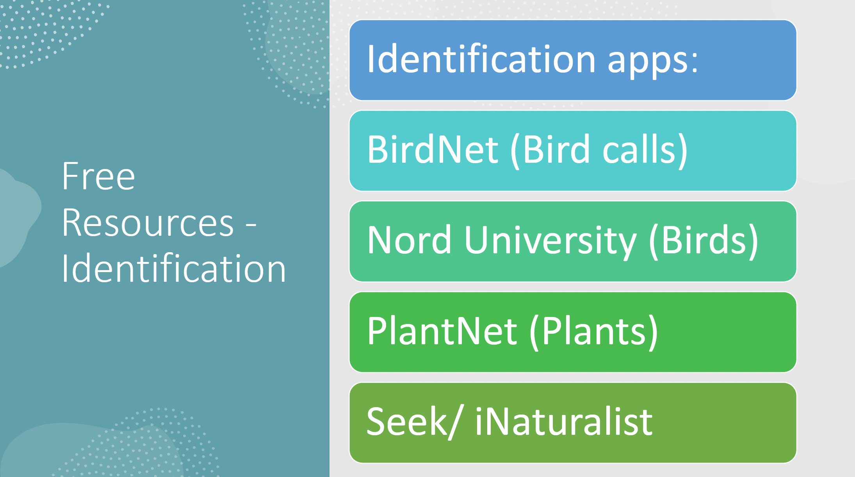

Links to some UK & Ireland ID Guides/Keys:

- Field Studies Council - https://www.field-studies-council.org/shop/
- NBDC Shop - https://www.biodiversityireland.ie/shop/

